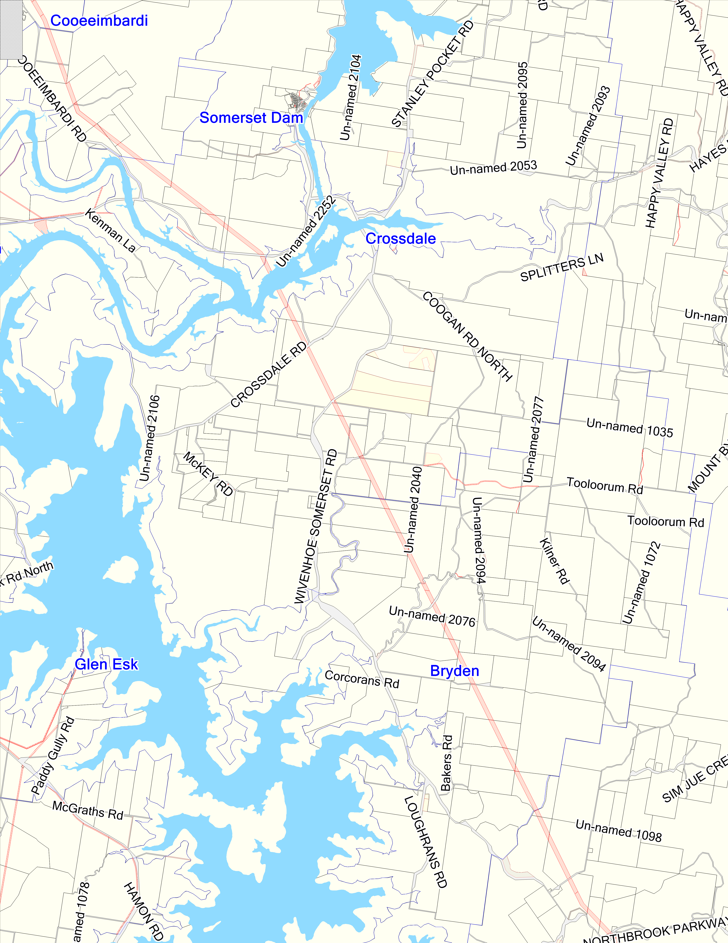
 | PO Box 117  2 Redbank St  Esk QLD 4312  Ph.07 5424 4000  Fax.07 5424 4099

Map Zoom Width: 17.56 km
1:103,300

Tuesday, 27 July 2010

Disclaimer
This information has been prepared for Council's internal purposes and for no other purpose. No statement is made about the accuracy or suitability of the information for use for any purpose (whether the purpose has been notified to Council or not). While every care is taken to ensure the accuracy of this data, neither the Council nor the Department of Natural Resources and Mines makes any representations or warranties about its accuracy, reliability, completeness or suitability for any particular purpose and disclaims all responsibility and all liability (including without limitation, liability in negligence) for all expenses, losses, damages (including indirect or consequential damage) and costs which you might incur as a result of the data being inaccurate or incomplete in any way and for any reason. © The State of Queensland (Department of Environment and Resource Management) 2010, © Somerset Regional Council 2010.

